Breakaway Farm Enterprises
Summer Riding Camp
Camper Information ( Short)
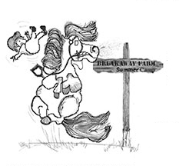
WARNING
Under Vermont Law, an equine activity sponsor is not liable for an injury to, or the death of, a participant in equine activities resulting from the inherent risks of equine activities that are obvious and necessary, pursuant to 12 V.S.A. § 1039.
Camper Name _____________________________________
Camper Age _______________________________________

Riding ability can be best described as: Beginner, Advanced Beginner, Intermediate
Riding Style: Western English

Parent One Name_________________________________________________
Parent One Emergency Phone Number: __________________________________

Parent Two Name _________________________________________________
Parent One Emergency Phone Number

Alternative Emergency Contact Name_______________________________________________
Alternative Emergency Contact Phone Number____________________________

Sessions attending (circle one or more):
Session 1 June 26th to June 30th
Session 2 July 10th to July 14th
Session 3 July 17th to July21rd

